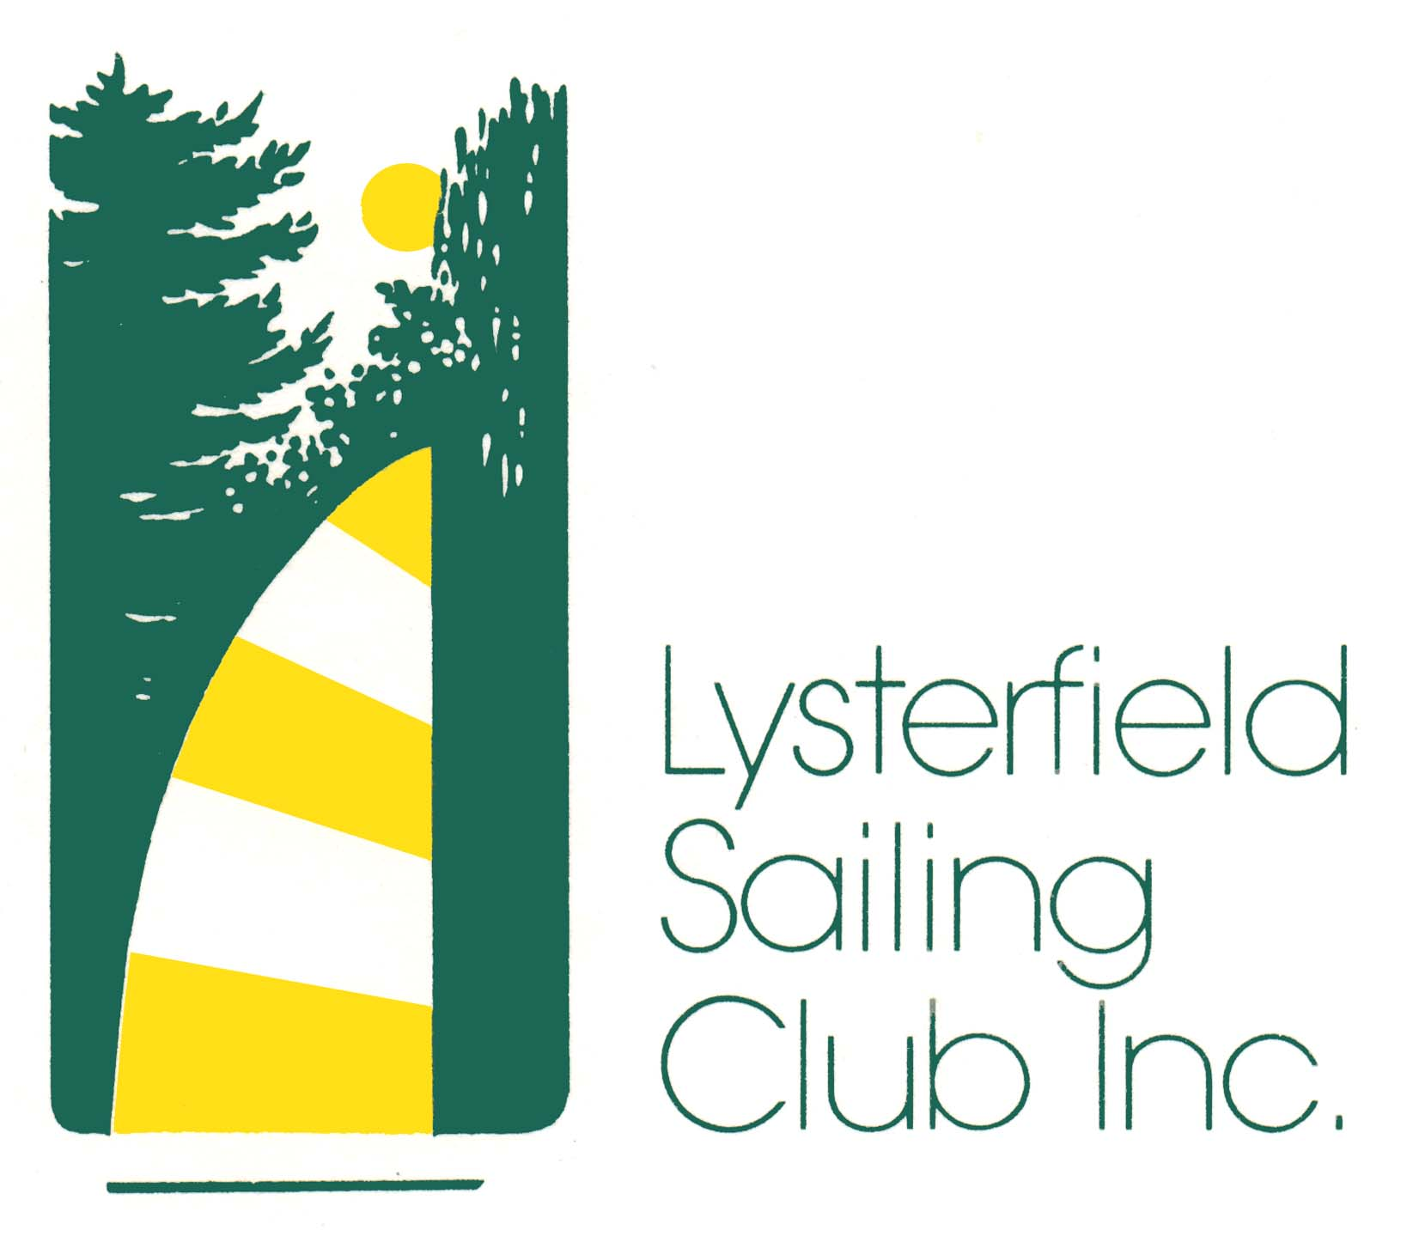

SAFETY & EMERGENCY RESPONSE PLAN

September 2013

LYSTERFIELD SAILING CLUB INC

SAFETY & EMERGENCY RESPONSE PLAN

INTRODUCTION

This Safety & Emergency Response Plan shall be read in conjunction with the Lysterfield Sailing Club Inc.Risk Management Plan, Yachting Australia Special Regulations Part 2 for “Off The Beach Boats” and Parks Victoria, Emergency Management Plan that includes Lysterfield Park.
(A copy of each of these documents is located in the Bookcase in the Meeting Room).

The aim of this, the Lysterfield Sailing Club Inc. Safety & Emergency Response Plan (“the Plan”) is to ensure the safety of the Club’s members, volunteers and participants, (“members and participants”) under the Club’s Sailing Events, Sailing School and Sailability Programs (“Club Events”) and visitors to the Club.

It must be recognised that the prime aim of the Plan is to provide assistance to Club Members managing Club Events and incidents relating to boating and the personal safety of members and participants in Club Events.

This Safety & Emergency Response Plan is not a substitute for common sense or crisis management. It must be recognised that the prime aim of this Plan is to minimise the effect of an emergency and to protect life.

Members and participants must keep aware that Lysterfield Park is a public park. Under the provisions of the Club’s Event Permit, Parks Victoria may review lake usage subject to prevailing weather conditions, if it is considered that an event will place park users at risk.

INDEMNITY

Notwithstanding the foregoing, it must be recognized that members and participants in the Club’s events do so at their own risk. Injuries to participants and damage to boats can and do often happen. The Lysterfield Sailing Club Inc, accepts no liability for any loss, damage or injury that may occur to any person or property whether onshore or afloat as a consequence of participation in Club Events (Sailing Events, Sailing School and Sailability Programs) and the Lysterfield Sailing Club Inc. disclaims any and all such liability.

GENERAL SAFETY REQUIREMENTS

All members and participants in Club Events shall comply with the following matters that the Club has identified as a high risk of harm or injury.

- For safety sake, please ensure that all children are properly supervised at all times. There are many hazards that can befall children, ranging from minor injuries,
near boats being rigged / unrigged, up to a more serious injuries, and even drowning;

- There is sufficient room for all competitors to rig their boats on the allocated grassed areas. Access to the main public pathway between the grassed areas and the trees is to be kept clear at all times and all spaces properly utilised. Select a space with enough room to walk around your boat but do not let your boat, its equipment and sails and launching trolley to protrude on to the public pathway. Road trailers are to be parked with the members and participant’s motor vehicles in the Parks Victoria designated car / trailer parking area. Launching trolley’s must not be left in the water whilst the member / participant is participating in a Club Event

GENERAL SAFETY REQUIREMENTS (CONT’D)

- Members and participants shall also be vigilant in respect of used needles and glass (broken) bottles being disposed of in the grassed areas, on the pathways and in the water. The danger of needle stick injury or the cutting of your feet requires all members and participants who enter events at the Club to wear adequate covered footwear;

- All crew members and participants whilst afloat, shall wear a Personal Flotation Device (PFD) secured about their persons in a manner appropriate to the design of the device and complying with an Australian Standard as specified under Regulation 5.01.02 of Yachting Australia Special Regulation Part 2 for “Off the Beach Boats”.

- In high winds, lower and secure your sails before you leave your boat unattended, otherwise it is dangerous to other boats and especially people in the vicinity;

- Boats manoeuvring near a shore, or leaving or returning to land shall exercise caution when in close proximity to members of the public;

- For those members who are rostered for crew duty on the rescue boat they must come prepared to go into what could be deep cold water to carry out rescue assistance and should wear a wetsuit or clothing suitable for the prevailing weather conditions. For safety reasons, only those members actually rostered on duty, or their replacements, are permitted on the rescue boat.

OWNERS RESPONSIBILITY

The safety of a boat and her crew is the sole and inescapable responsibility of the owner and the person in charge who must do their best to ensure that the boat is structurally sound, thoroughly seaworthy and manned by an experienced crew who are physically fit to face the expected conditions. The owner and the person in charge must be satisfied as to the soundness of the hull, spars, rigging sales and all gear. The owner and the person in charge must ensure that all safety equipment is properly stowed and that the crew knows how to use it.

Neither the establishment of the Special Regulations, their use in approved Club events, nor the inspection of a boat under these Regulations in any way limits or reduces the complete and unlimited responsibility of the owner and the person in charge.

“The responsible for a boat’s decision to race or to continue racing is hers alone” (Fundamental Rule 4- Racing Rules of Sailing).

CLUB RACING EVENTS

All Club racing events shall be conducted under the appropriate Yachting Australia Race Safety Category 7 unless specified otherwise in the Notice of Race.
Category 7 is defined as - Short races in sheltered waters, in daylight hours only.

Club Events are generally conducted using a Starting Boat. The Officer of the Day must also ensure that there is effective rescue capability availability.

Prior to the commencement of any race, all boats entries must be verified for boat name, sail number and skippers name made on the official entry form (Sign on Sheet) in accordance with Clause 3.2 of the Club’s Sailing Instructions – Club Racing

WEATHER FORECAST / WIND LIMITS / FOUL WEATHER

The Officer of the Day should obtain the latest possible weather forecast and wind strength report on the day of the race from the Club’s weather station in the Control Tower.

Club Officials, race officers, members and participants in Club Events often ask at what wind strength should racing be call off but, of course, it is not that simple as there are competing demands and many factors to be considered.

For example, safety is not well served by always calling off Club Events when the wind gets up as this will result in members and participants never gaining the skills required to handle their boats in a range of conditions. In addition, part of the enjoyment of sailing is the satisfaction of sailing is exercising the skills necessary to handle the boat in more demanding conditions.

When considering whether conditions might be unsuitable for Club Events, wind strength alone is not necessarily a good indicator of risk and there are a number of factors to be taken into account – and are set out in the Club’s Risk Management Plan.

In the event of Foul Weather, including but not limited to strong winds, wind / lightning storms, the onset of unusually cold weather or for any other reason directly affecting the safety of members and participants during a Club event, the Club’s Officer of the Day shall abandon the race in accordance with Clause 12.1 of the Club’s Sailing Instructions.

Similarly, in respect of the Club’s Sailing School and Sailability Programs the Sailing School Coordinator or the Sailability Team Leader as the case may be, shall terminate the program for that day.

BUSH FIRES

In the event of a Bush Fire within the Lysterfield Park and likely to affect the safety of the Club’s members and participants, it is the policy of the Club, based on advice from Parks Victoria, to abandon all activities on that day and to turn away any member and / or participant not contacted prior to the event and prior to their entry into the Park.

Should a fire become active and thereby placing the safety of members and participants during a Club sailing event at risk, the Club’s Officer of the Day shall abandon the race in accordance with Clause 12.1 of the Club’s Sailing Instructions.

Similarly, in respect of the Club’s Sailing School and Sailability Programs, the Sailing School Coordinator or the Sailability Team Leader as the case may be, shall terminate the program for that day.

While it is safe to do so, the Officer of the Day, Sailing School Coordinator, Sailability Team Leader, as the case may be, will arrange to properly secure the Club’s assets and facilities within the “Compound” and members and participants will be required to un-rig their boats, pack-up, and remove their boats, trailers and motor vehicles from the Park as a matter of urgency.

Should this not be possible then the members and participants must consider their own personal safety including access from the Park, taking into account their need to:

BUSH FIRES (CONT’D)

- save their motor vehicle, abandon their boat and vacate the Park;

- save their boat by sailing to the middle of the dam wall, get out of their boat, lower the sail (s) hold onto their boat until the fire passes and then return to the
shore, un-rig, pack- up and vacate the Park when instructed to do so by the
appropriate authority; and

- find a safe place by entering the water in front of or near the rigging area and stay there until the danger passes or until rescued.

The responsible Control Agency in the case of bush fires within the Parks area is the Country Fire Authority with Parks Victoria being the Support Agency.

CODE RED DAYS

Code Red days are very rare and very serious. In the event of a Code Red Day being declared Parks Victoria will close the Park and all Club events will be abandoned.

BLUE GREEN ALGAE OUTBREAK / E.COLI OUTBREAK

Should an outbreak of either Blue Green Algae or E-coli occur and following a period of water sampling reach cell count levels making it unsuitable for primary contact and recreational use, Parks Victoria will notify the Club and close the Lake until such time as it is safe for the Club to recommence its events programs.

MEMBER PROTECTION POLICY / INCIDENT REPORTING

All members and participants are to be aware of the Club’s Risk Management Policy and Yachting Australia Member Protection Policy, (A copy of these documents are also in the Bookcase in the Meeting Room), that requires, amongst other things, that members and participants do not contribute to, intervene in the outbreak of, or encourage any public disobedience, misbehaviour, violence, and other threats; and report any incident in the first instance to the Officer of the Day or a Senior Officer of the Club who will inform the Police and subsequently Parks Victoria.

RESCUE BOAT OPERATIONS / INCIDENT REPORTING

- Rescue Boat Operators Instructions

Common sense and sailing experience are important factors in assessing a situation of a capsized boat or crew in distress.

- The rescue boat crew must check the First Aid equipment on board the rescue boat;

- When approaching a capsized boat or crew in distress the rescue boat crew should:

Always ask permission to assist, and if refused, back off and observe. If assistance is accepted to take control of the situation – the welfare of the crew being of the highest priority;

- When rendering assistance to the crew of the capsized / damaged boat the rescue boat crew must:

  - Be conscious of the propeller position and turn the motor off if dangerous;
  - Be aware of trailing sheets, ropes, sails or any floating equipment;
Rescue Boat Operators Instructions (Cont’d)

  - Use a member of the rescue boat crew to give “in water” assistance, if required;
  - Medically assist rescued crew first, if required, and bring them on ashore, if injured;

    - When rendering assistance to the boat:

      - Instruct crew of the capsizes / damaged boat to hold onto the bow to swing
the boat into the wind and instruct the crew to try to right the boat.

2. In strong winds approach the capsized / damaged boat on the lee side to
avoid being blown on to it. If its sail is floating, grip the top of the mast and
maneuver so that the rescue boat is on the windward side. Now hand over
hand walk down the underneath side stay and with the help of the wind the
boat should right itself;

3. In light winds approach on the windward side or to the top of the mast. If the
sail is floating, repeat the instruction in (2) above. If the boat is fully
capsized then the side pressure of the rescue boat will assist in righting the
capsized boat. As soon as the top side stay is visible hand over hand walk
up the side stay to the top of the mast while pushing the boat away from the
rescue boat. Once at the top of the mast, repeat the instruction in (2) above.

  - On our Lake the rescue boat can always tow a capsized / damaged boat
slowly to the shore. This can be done by securing the capsized / damage
boat’s tow rope through the towing ring, fixed at the front to the boat to the
stern of the rescue boat. Remember - take it slowly

The Officer of the Day, Sailing School Coordinator or Sailability Team leader(s), as the case may be, shall at the conclusion of each days Club Event complete and submit to the Club Official responsible for Safety and Emergency Management, an Incident Report as detailed in Appendix 1.Copies are located in the Control Tower and in the Bookcase in the Meeting Room.

DUTY OF CARE

Notwithstanding the provisions of the Rule 4 of the Racing Rules of Sailing that states
“ The responsibility for a boat’s decision to race or to continue racing is hers alone”
the Lysterfield Sailing Club Inc owes a Duty of Care to members and participants in an approved Club Event and associated activities where there is a reasonable foreseeable risk of harm or injury to members and participants as a result of the actions of the Club and its officials.

In exercising this Duty of Care, the law requires the Club and its Officials to take reasonable steps to reduce the likelihood of injury to members and participants as a result of those risks that are foreseeable.

CONTACTS

The Officer of the Day, Sailing School Coordinator on a Saturday event or the Team Leader, Sailability Program on a Friday or a Sunday event can be contacted on the Club’s
Mobile No. 0434 846 653.

The Team Leader, Sailability Program on a Wednesday event can be contacted on the Club’s other Mobile No. 0468 954 416.

The Club contact numbers are otherwise:

Commodore: Mark Ferguson. Tele: 5944 4567. Mobile No. 0438 396 029

Secretary: Peter Reid. Tele: 9720 3201. Mobile No.0403 638 394

The Club may also be contacted during a Club event by communicating personally with the Officer of the Day in the Race Control Tower or the Sailing School Coordinator at the activity center on the shore where a two – way radio communication is available to the rescue boat.

This Safety and Emergency Response Plan replaces the updated Safety Plan dated 19 April 2012

LYSTERFIELD SAILING CLUB INC

INCIDENT REPORT

Details of Reporting Club Official / Sailing School Coordinator /

Sailability Team Leader
Name: Date: Time:
Details of Incident:
Details of Personal Injury:

Details of Any Personal Property Damage:
Area of Incident:
Personal Details of Injured Person (s):

Name of Member / Volunteer / Visitor:
Address:
Telephone / Mobile No:

